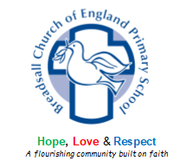

Phonics and Early Reading at Breadsall

Phonics Intent Statement

The Five Principles | Purpose – know the purpose of every activity and share it with the children, so they know the one thing they should be thinking about  Participation – ensure every child participates throughout the lesson. Partnership work is fundamental to learning  Praise – ensure children are praised for effort and learning, not ability  Pace – teach at an effective pace and devote every moment to teaching and learning  Passion – be passionate about teaching so children can be engaged emotionally.
At Breadsall C of E Primary School, we use a synthetic phonics programme called Read, Write, Inc. Read, Write, Inc. is a method of learning based upon a knowledge of how letters and sounds blend together to enable us to read and write words. Using this strategy, the children will learn to recognise a wide range of grapheme-phoneme correspondences and will start to read with greater accuracy and fluency. Throughout the programme, they will learn how to use their knowledge of phonemes (sounds) to select the correct graphemes (letters), in order to encode correctly for spelling. This will encourage children to focus on composing what they write. The children are assessed regularly, and grouped according to their phonic ability and level of fluency, and will learn to read in a small group with a teacher or teaching assistant. The Reading Leader will monitor teaching and learning consistently, providing targeted support, where necessary, to ensure that the children move through the programme at a good pace. At the end of each half termly assessment, the children will move into their new groups based on their progress. By the end of the year, most teachers will have had the opportunity to teach a range of different groups and as a result, have a clear vision of where the children have come from and what they need in order to progress.

Intent | Implementation | Impact
Word reading  Children learn a simple alphabetic code followed later by a more complex code. All reading books progress cumulatively, matched to the sounds children know.  Language comprehension  We help children to enjoy stories and poems from the minute they come into school. We know and love the books we read aloud, so children will want to hear the same story again and again.  We use similar emphasis and intonation on each reading, so children can join in the retelling.  Our picture books are for all children, whether they can read or not. For those who are still learning to read, we help them retell the story. For children who are able to read, we encourage them to enjoy reading and to retell the story events. | Word Reading  We organise Read Write Inc. books and resources in a central area.  All books read in RWI lessons progress according to the children’s phonic knowledge and skills. These are then taken home for children to re-read to feel successful and to read with increased fluency.  We also provide decodable RWI book bag books for the children to take home. These all link contextually to their phonics books.  All phonics reading books are decodable, linked with each stage of the children’s phonic knowledge.  Language Comprehension  Each RWI story book includes key comprehension questions.  As a staff, we share stories and poems to children with love, confidence and enjoyment, every day.  We organise parent workshops to support parents, suggest recommended reads at home and ensure that they understand how important story time is at home. | Word reading  We aim for Read Write Inc. phonics to be redundant for the majority of our children, by the end of the Autumn Term in Year 2. However, identified Year 2 and KS2 children who still require further support with phonics, also access RWI through 1:1 intervention.  Language comprehension  Teachers;  - Know the importance of reading stories to their children every day.  - Know how to engage children in stories when reading aloud.  Parents;  - Know the importance of reading stories to their children at home  - Know how to read stories to their children.  - Read with their children most evenings.  Children;  - Are able to read books in line with their phonic knowledge and with increasing fluency.  - Enjoy listening to stories and poems.  - Can join in with many stories and poems.  - Learn new vocabulary.


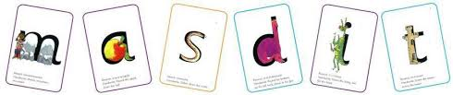
Read, Write, Inc. Lessons
Reading
We begin by teaching the children set 1 sounds. Children can start blending sounds into words as soon as they know a small group of letters well. Once the children have been taught the first 5 sounds (m, a, s, d, t), they are then taught assisted blending using the sounds that they know. During lessons children are taught to hear sounds and blend them together in sequence to make a word. We start with blending oral sounds, then progress to reading the letters and blending them together to read the word.
Order of teaching sounds
In Read Write Inc phonics the individual sounds are called ‘speed sounds’ – because we want the children to read them effortlessly. Set 1 sounds are the single letter sounds and set 1 special friend sounds. They are taught in the following order;
m, a, s, d, t, i, n, p, g, o, c, k, u, b, f, e, l, h, sh, r, j, v, y, w, th, z, ch, qu, x, ng, nk.

There are 12 Set 2 ‘speed sounds’ that are made up of two or three letters which represent just one sound, e.g. ay as in play, ee as in tree and igh as in high. These are ‘special friend’ sounds.
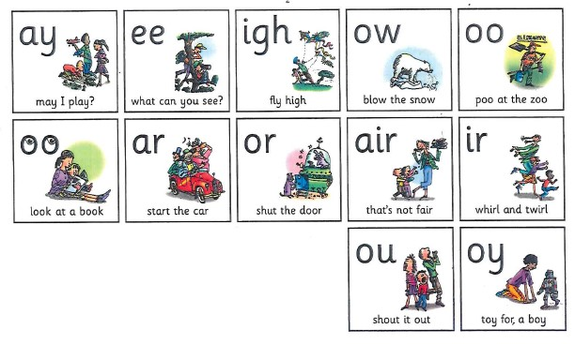
When children are taught Set 2 sounds they will learn:
- a simple picture prompt linked to the sound
- a short phrase to say e.g. may I play
- the letters that represent a sound (special friends) e.g. ay

Each sound has a list of green words linked to it, so that the children have the opportunity to sound out and blend words containing the new sound they have been taught, for example, s-p-r-ay = spray.

When learning Set 3 speed sounds the children will be taught alternative sounds/graphemes, e.g. ee as in tree and ea as in tea.

The tables below show each sound, the associated phrase and example green words for set 1 special friend sounds, set 2 and 3 sounds and additional sounds that are taught.
Set 1 ‘Special Friend’ Sounds
Sound | Phrase | Green words
sh | *handwriting phrase | ship, shop,
th | *handwriting phrase | thing, thin,
ch | *handwriting phrase | chip, chop, champ,
qu | *handwriting phrase | queen, quack, quest
ng | Thing on a string | thing, string, ring, king
nk | I think I stink | Stink, think, link, sink

Set 2 Sounds
Sound | Phrase | Green words
ay | May I play? | day, say, play, tray, today
ee | What can you see? | see, feel, need, sleep, three
igh | Fly high | night, fight, flight, high
ow | Blow the snow | show, blow, flow, snow
oo | Poo at the zoo | zoom, moon, food, cool
oo | Look at a book | look, book, good, hood
ar | Start the car | star, bar, car, start, cart
or | Shut the door | sort, short, worn, horse
air | That’s not fair | fair, hair, chair, stair
ir | Whirl and twirl | whirl, twirl, shirt, skirt
ou | Shout it out | mouth, found, shout, loud
oy | Toy for a boy | toy, boy, employ, joy

Set 3 Sounds
Sound | Phrase | Green words
a_e | Make a cake | make, cake, flake, bake
ea | Cup of tea | neat, real, clean, please
i_e | Nice smile | hide, shine, white, nice
o_e | Phone home | phone, bone, home, spoke
u_e | Huge brute | tune, rude, June, perfume
aw | Yawn at dawn | saw, law, raw, straw
are | Share and care | bare, spare, scare, flare
ur | Nurse with a purse | burn, turn, hurl, burp, lurk
ow | Brown cow | howl, down, brown, frown
oi | Spoil the boy | join, coin, voice, choice
ai | Snail in the rain | paint, train, rain, pain
e | e: he, she, me, be, we | he, she, we, be, me
oa | Goat in a boat | coat, throat, boat, float
ew | Chew the stew | flew, blew, crew, new
er | A better letter | over, weather, never
ire | Fire, fire! | spire, conspire, hire, fire
ear | Hear with your ear | fear, dear, gear, spear
ure | Sure it’s pure | picture, mixture, adventure

Additional sounds
Sound | Phrase | Green words
ue | Come to the rescue! | rescue, blue, glue, clue
ie | Terrible tie! | ties, tried, pie, lie
au | Paul the astronaut | Paul, August, author, pause
e_e | Go Steve and Pete! | even, Steve, Pete, theme
kn | Knock knock, who’s there? | knight, knee, knock, knit, knot
ck | Tick tock clock | clock, pick, black, snack
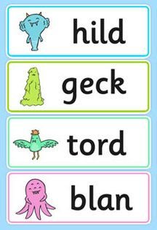
Nonsense words (Alien words)
As children build up their knowledge of sounds they are able to apply their decoding skills to any unfamiliar word, whether it be real or nonsense. During lessons each day children will practice their decoding skills by sounding out nonsense words. Children are unable to rely on existing knowledge of real words, and instead have to use their letter-sound knowledge. This is an important part of the Phonics Screening Check that the children complete at the end of year 1.

Learning to blend and Ditty Books
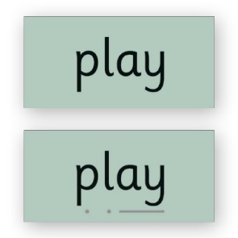
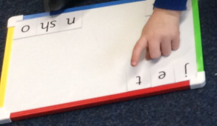
As soon as children have been taught a few initial letter sounds they begin to learn to blend the sounds together to read real words in a Word Time session. Each word time session involves oral blending of known sounds before they are shown the words written down on green cards. Children practice Fred talking the words until they become able to read them on sight. Ditty lessons follow on from this where children who are becoming excellent at reading single words are introduced to reading short sentences. Once children are confident reading the short sentences they are challenged to use their developing phonic knowledge to write a sentence.

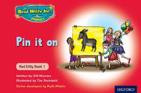
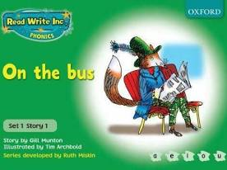
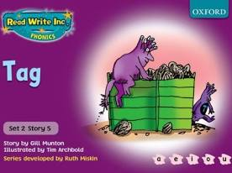
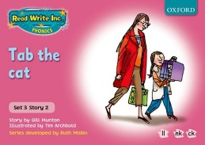
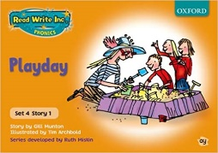
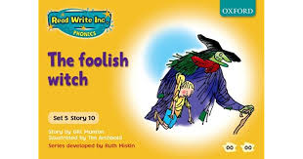
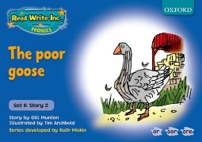
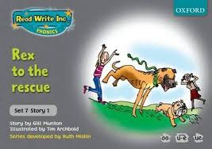
Storybook Lessons
After ditty books, the next stage is storybooks. These books are closely matched to their developing phonic knowledge. The storybooks consist of green words linked to the sounds that they have been learning, red words and challenge words to extend the children’s vocabulary. After children have practiced these words individually they are prepared to see them in context in the story. Comprehension activities, partner discussion and writing activities based on the book, follow on from reading.
Reading into writing
Within our phonics lessons we model using ‘Fred fingers’ for spelling, which we then encourage the children to use as a strategy outside of phonics lessons.
We also use ‘hold a sentence’ which encourages the children to remember a whole sentence while focusing on spelling and punctuation.
Phonics speed sound charts are used outside of the phonics session and across the curriculum to help children to link what they have learnt in phonics to their writing.
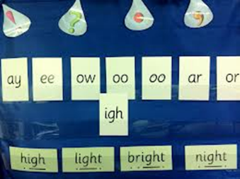
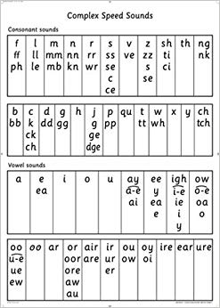
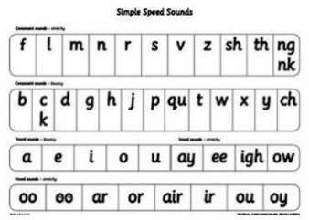
Learning environment
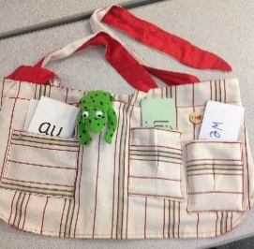

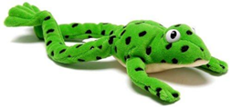
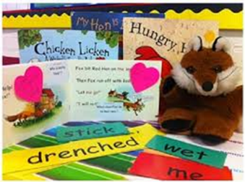
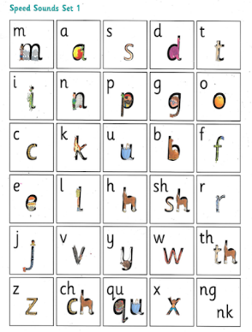

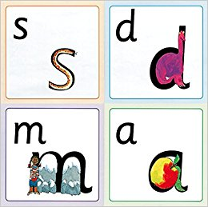

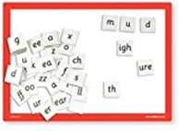
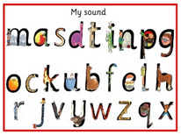

Glossary:
phoneme- The smallest unit of sound in a word. The word ‘church’ has 3 phonemes (sounds) ch-ur-ch.

grapheme- The letter or letters used to represent the phoneme in written form.

fluency- reading with accuracy (reading words correctly), automaticity (reading words at an appropriate speed without great effort) and prosody (appropriate stress and intonation).
decode- Using knowledge of letter and sound relationships to identify sounds and to read words.

encode- The process of hearing a sound and being able to write a symbol to represent that sound.

