bbn
English (Reading, Writing, Speaking & Listening)
Linking in with our history topic, the class book for this term is ‘Goodnight Mr Tom’.
Over this term, children will be learning how to write a variety of different genres including:
Recounts/diary entries
Fiction
Poetry
Descriptions
Non-fiction – explanation texts
Some of these genres will lend themselves to exploring our World War II topic further. For example, children could write an explanation text about what to do when there is a blackout during the Blitz or a fictional account of an evacuee experience.

Mathematics:
Pupils in Year 5 and Year 6 will become secure with:
- Place value up to 1,000,000
- Add/subtract numbers with more than 4 digits
- Multiply and divide by 10, 100 and 1000
- Fractions: find equivalents and convert
- Place value up to 10,000,000
- Complex calculations using all 4 operations
- Fractions: divide/multiply fractions
- Exploring imperial and metric measures

Science:
Scientific enquiry will be taught through learning about:
Light: children will identify light sources and investigate how light travels from that source; they will revise how shadows are formed and explore how light is reflected and refracted. They will also find out about how we see things and about the structure of the eye.
Electricity: children will draw circuits using symbols and construct series and parallel circuits; they will investigate the effects of changing the number of components in a circuit.

Art & Design: WWII
Using paintings and sculptures from the artist Henry Moore, children will explore shading, shadow and perspective to produce their own piece of art. They will create sculptures based on the painting ‘Shelter’.

History: The Battle of Britain (WWII)

Children will learn about events leading up to the outbreak of war in 1939. They will use a range of resources including newspaper reports, books, letters and artefacts to learn what life was like in England during the time of the Battle of Britain. This will include looking at the impact of rationing and the ‘Dig for Victory’ campaign, the evacuation of children from cities, the changing role of women and the impact of the war on Derby and Breadsall.

Oak Class – Autumn Term
(Year 5/6)
Why did the Battle of Britain take place?
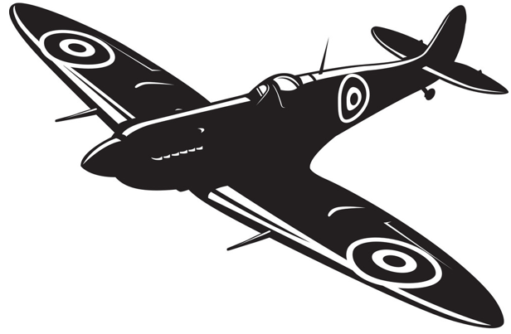
Term: Autumn 2021

Computing:
Y5 – Sharing information and Vector drawing
Y6 – Communication and 3D Modelling
Computer Systems and Networks: Sharing Information
Creating Media: Vector Drawing

Year 6
Computer Systems and Networks: Communication
Creating Media: 3D Modelling

Design & Technology
Children will plan, design and make a vehicle that moves (linked to work on circuits and WW2)

MFL – French:
All about Ourselves (written and oral descriptions of themselves)
Family and Friends
PE:
Swimming (Year 5 only)
Tag Rugby
RE:
God
What does it mean if God is holy and Loving?

Incarnation
Was Jesus the Messiah?

Music
At the Movies
Children will explore the impact of music in films and how this has evolved and changed over the decades.

PSHE:
It’s My Body
Safety First

