bbn
Mathematics:
Y5: Children will use formal methods to multiply a four-digit number by a two-digit number and divide a 4-digit number by a one-digit number. Children will learn how to multiply and divide fractions and recognise equivalent fractions and decimals. Children will begin to work with decimals to three decimal places and percentages. Children will calculate area, perimeter and interpret line graphs. Y6: Children will calculate ratio and proportion and will study algebra, including developing a rule, using formulae and solving equations. Children will learn how to add, subtract, multiply and divide decimals as well as understanding equivalent fractions, decimals and percentages. Children will calculate area and perimeter of triangles and parallelograms and missing lengths.

Science:
Scientific enquiry will be taught through learning to:
- Identify and name the main parts of the human circulatory system and describe the functions of the heart, blood vessels and blood.
- Recognise the impact of diet, exercise, drugs and lifestyle on the way their bodies function
- Describe the ways in which nutrients and water are transported within the human body.
- describe the changes as humans develop to old age.

English (Reading, Writing, Speaking & Listening)

Linking in with our history topic, The Golden Age, our class book will be ‘Tales from the Arabian Nights’ We will practise our reading skills using these tales.

Children will read texts and write in the style of the following genres:
- Letter writing (persuasive)
- Fictional writing
- Book review
- Tales from other Cultures (Asian)

Pupils will also celebrate Word Book Day.

Art & Design: creating repeating geometric and symmetrical patterns; calligraphy; children will learn about the history of paper making (history topic link) and will make their own paper using a range of materials.

History:
Children will study a Non-European society that provides a contrast with British history. They will learn about the growth of the early civilisation in Baghdad (about AD 900), including the location, history of leaders, the lives of everyday people, trade and the Golden Age of learning in Baghdad (the House of Wisdom, the development of medicine and the contribution to mathematics), as well as charting the end of the civilisation.

Oak Class (Year 5/6)
Why is the early civilisation in Baghdad (AD900) known as the ‘Golden Age’?
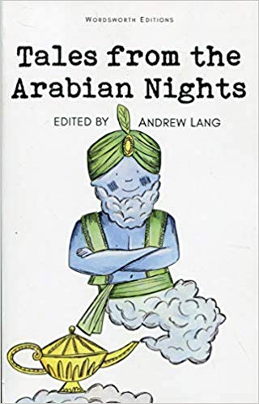
Term: Spring 2026

Computing:
Coding using Scratch
Internet Safety Day in February

Design & Technology: Healthy Heart & Healthy Diet (linked to science). Children will use a range of skills and follow simple recipes to create ‘healthy heart’ dishes that reflect traditional dishes from across the UK.

PE: Swimming (Y5 until Feb half-term). Team work, communication and problem solving activities.

MFL – French:
Time Travel – pupils will learn numbers up to 2000 and use these to relate to historical events as they explore key events in French history as well as “visiting” a French town

RE: Understanding Christianity

Why is the Torah important to Jewish people?
Salvation: What did Jesus do to save human beings? (Y5)
What difference does resurrection make for Christians? (Y6)
PSHE: Module: It’s my body
This unit involves discussions around consent, the importance of sleep and exercise, how to take care of our bodies, how substances can harm our bodies and how to make healthy choices. Discussions around how we think and feel about our bodies will be happening.

Music – Living on a Prayer
We will be learning about 6 different rock related songs experimenting with playing instrumental parts, adapting songs and composing our own parts to these songs.

