bbn
English (Reading, Writing, Speaking & Listening)
Linking in with our geography topic, Coast, our class book will be ‘The Wreck of the Zanzibar’ by Michael Morpurgo. We will complete writing units based on writing to inform and persuade including:
- Leaflet/poster outlining different coastal features
- Save the animals! Beach combers.
- Informal letter based on The Wreck of the Zanzibar (from Laura’s perspective)
- Advert – Why you should visit the Isles of Scilly – leaflet
Year 5 will complete unit based on War Horse during Y6 SATS preparation.

Science: Living Things and Their Habitats
Scientific enquiry will be taught through learning to:
- describe how living things are classified into broad groups according to common observable characteristics and based on similarities and differences, including micro-organisms, plants and animals.
- observe and compare life cycles of plants and animals in their local area and compare with other plants and animals around the world.
- describe different types of reproduction in plants and animals.

Mathematics:
Year 5:
The remaining Year 5 units include: Perimeter and area, Graphs and tables, Geometry: properties of shapes, Position and direction, Decimals, Negative number and Measure: converting units.

Year 6:
In the four weeks leading up to SATS, Year 6 will be learning:
- Measure: Area, perimeter and volume of shapes
- Statistics: including pie charts, line graphs and averages
- Geometry: properties of shapes, nets, angles, parts of circles, coordinates
- SATS Revision and preparation

Art & Design: taking the sea as inspiration, children will study the work of Cornish artists such as Alfred Wallis. They will produce pen and ink drawings of fish, use pastels to draw shells and make printing blocks of sea creatures.

Geography:
Children will understand geographical similarities and differences through the study of human and physical geography of our local area and the Isles of Scilly.
Children will learn about the processes of erosion and deposition and how these change our landscapes, with particular reference to coasts. They will read and draw maps, use and create keys use grid references and compass points, study weather information, research about wildlife and learn about industries to compare and contrast locations.

Oak Class (Year 5/6)
COAST
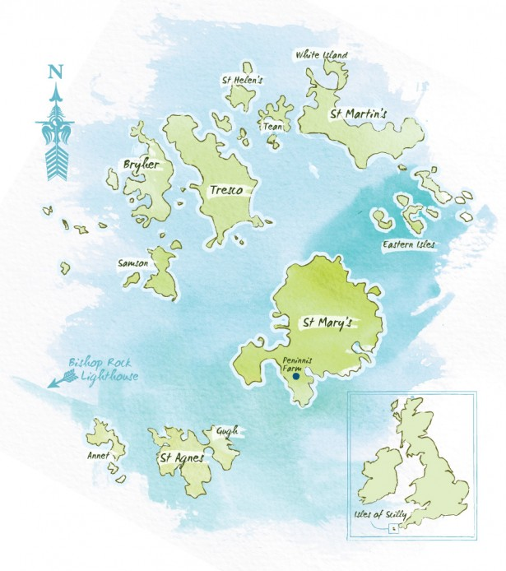

Term: SUMMER 2026

Computing:

Year 5 – Flowol – understanding flowcharts
Year 6 – Spreadsheets

Design & Technology:
Design, make, evaluate and refine a marble run from a variety of materials.

PE: Tennis – we have a great opportunity to work with a Tennis coach this term. Year 5 April-half-term in May. Year 6, after May half-term until the end of the year. Orienteering and outdoor and adventurous activities will be taught as part of the residential visit to Lea Green in July.

MFL – French:
All in a day: pupils learn to tell the time in French
Let’s go shopping: revise numbers in the context of going shopping. Learn the vocabulary connected to buying clothes, food and toys.

RE:
Expressing: Is it better to express your religion in arts and architecture or in charity and generosity?

Kingdom of God
What kind of King is Jesus?

Music

End of Year production.

PSHE:
- Growing up, including puberty (sex education)
- Money Matters (budgeting, spending, debt and being a responsible consumer)

